22AIE301 — PROBABILISTIC REASONING
BP-Verify
Belief Propagation for Verifying Multi-Step LLM Reasoning Chains
The Complete Project Guide — Concepts, Base Paper, Novelty, Approach, Stack & Timeline
Amrita School of Artificial Intelligence, Coimbatore · 22AIE301 Probabilistic Reasoning
19 July 2026

Table of Contents

0. Project Overview
When an LLM answers a hard question by reasoning through several steps, a mistake usually hides in one weak link, not spread evenly across the whole chain. This project builds a system that turns an LLM's reasoning into an explicit graph of claims, asks the LLM for its own confidence on each claim, and then runs belief propagation — the exact algorithm your syllabus teaches — to work out a corrected, logically-consistent probability that the final answer is actually trustworthy.
It is built directly on top of a real, peer-reviewed method (BTProp, NAACL 2025), which already proves the core idea works on standalone factual statements. Our contribution is extending it to handle real, branching multi-step reasoning (not just simple statement trees) and making it cheaper to run — both directions the original authors either couldn't do or explicitly flagged as future work.
This document is meant to be everything you need before writing a single line of code: the concepts from first principles, a complete and accurate breakdown of the base paper (verified against the actual paper text, not reconstructed from memory), exactly where it falls short, what we're changing, a step-by-step build plan, the tools you'll need, and a phase-by-phase timeline.

1. Concepts & Terminology — Complete Primer
Read this section once, fully, before the base-paper breakdown in Section 2 — everything there builds on these ideas.

1.1 Probability Refresher
- Random variable: A quantity whose value is uncertain, e.g. “is this claim true?” The claim's truth is a random variable that is either True or False, and we're not sure which.
- Prior probability: What we believe about a variable before seeing any evidence — e.g. “before checking anything, is a random claim more likely true or false?”
- Posterior probability: What we believe after incorporating evidence — e.g. “given the LLM's confidence scores on this claim and its relatives, how likely is it true now?” This is the number the whole project ultimately computes.
- Bayes' Rule: The formula that turns a prior plus new evidence into a posterior. Every graphical-model inference algorithm, including belief propagation, is really Bayes' Rule applied efficiently and repeatedly across a graph instead of by hand.

1.2 Graphical Models, in One Picture
- Graphical model: A diagram where nodes are random variables and edges show which variables directly influence which others. The graph's shape tells you which variables can be reasoned about independently and which can't.
- Bayesian Network: A graphical model with directed edges (arrows) — your syllabus's first major topic. Each node's distribution depends on its parents.
- Markov Network / Markov Random Field (MRF): A graphical model with undirected edges — you don't pick a direction of “cause,” only that two variables are related.
- Factor graph: A more general representation with two kinds of nodes: variable nodes and factor nodes (functions describing how groups of variables relate). Both Bayesian networks and Markov networks can be rewritten as factor graphs, and belief propagation is most naturally described on a factor graph.
- Clique / potential function: In an MRF, a clique is a fully-connected subset of nodes, and a potential function assigns a compatibility score to each possible joint setting of that clique's variables — not used directly by BTProp's tree model, but the general machinery this project's DAG extension will need.

1.3 Trees, and Why They're Special
- Tree-structured graphical model: A graphical model with no cycles and exactly one parent per node. Trees are important because exact probabilistic inference on them is guaranteed to be fast and exact — no approximation needed.
- Belief propagation (BP) / the sum-product algorithm: A message-passing algorithm: each node sends a summary (“message”) of its current belief to its neighbours, and combines incoming messages to update its own belief. On a tree, running this once from the leaves to the root (and optionally back down) gives the exact posterior for every node.
- Loopy belief propagation: The same message-passing idea run on a general graph that DOES have cycles. It has no guarantee of converging to the exact answer, or of converging at all — but in practice it very often works well, and characterising when it does is itself a legitimate research question. This is exactly what our DAG extension (Section 3.1) needs.
- MAP vs. marginal inference: MAP (“maximum a posteriori”) asks for the single most likely full assignment of every hidden variable at once. Marginal inference asks for the probability of just one variable, averaged (summed) over all possibilities for every other variable. BTProp computes a marginal — the posterior probability of one specific node (the root claim) being true.
- Conditional independence: Two variables are conditionally independent given a third if, once you know the third, learning about one tells you nothing more about the other. Tree models assume a node's children are conditionally independent of each other given the parent — the assumption that makes exact tree inference tractable in the first place.

1.4 Hidden Markov Models: From Chain to Tree
- Hidden Markov Model (HMM), the syllabus version: A chain of hidden states (one per time step) that you can't observe directly, each producing a noisy observation you can see. Two kinds of probabilities define it: transition probabilities (how the hidden state changes from one step to the next) and emission probabilities (how likely a given observation is, given the hidden state that produced it).
- Hidden Markov Tree (HMT): Exactly the same idea, except the hidden states are arranged in a tree instead of a chain — each hidden node still has emission and transition probabilities, but a node can now have several children instead of just one successor. This is the exact model the base paper builds.
- The forward-backward / upward-downward algorithm: The standard exact inference algorithm for HMMs (chain case: forward-backward; tree case: upward-downward). It computes the posterior probability of every hidden state efficiently, without ever enumerating all possible hidden-state sequences by brute force.

1.5 LLM-Specific Terms You'll Need
- Hallucination: A statement an LLM generates that is factually incorrect, even though it may be phrased fluently and confidently.
- Chain-of-thought (CoT): Prompting an LLM to write out its reasoning step by step before giving a final answer, rather than answering directly.
- Calibration: How well a model's stated confidence matches its actual accuracy. A well-calibrated model that says “90% confident” is right about 90% of the time; LLMs are frequently miscalibrated — sometimes wildly overconfident.
- Confidence score / “belief”: A number in [0,1] representing how sure the LLM is that a statement is true, usually obtained either by directly asking the model or by reading the model's own next-token probabilities.
- Self-consistency: Sampling several different answers or reasoning paths from the same model and checking how often they agree, as a rough proxy for confidence — the basis of several baseline methods the base paper compares against.
- NLI (Natural Language Inference): The task of deciding whether one sentence (the hypothesis) is entailed by, contradicted by, or unrelated to (neutral with) another sentence (the premise). BTProp uses an off-the-shelf NLI model to work out logical relationships between claims.
- Entailment / contradiction / neutral / equivalence: The four possible logical relationships between two statements used throughout this project: entailment (one implies the other), contradiction (they can't both be true), neutral (unrelated), and equivalence (each implies the other).
- AUROC / AUC-PR: Standard metrics for a detection/classification task with a continuous score. AUROC measures how well the score ranks true cases above false cases; AUC-PR does the same but is more informative when the positive class (here, hallucinations) is rare.

2. The Base Paper, Completely Explained

2.1 Citation
Title: A Probabilistic Framework for LLM Hallucination Detection via Belief Tree Propagation (BTProp)
Authors: Bairu Hou (UC Santa Barbara), Yang Zhang (MIT-IBM Watson AI Lab), Jacob Andreas (MIT CSAIL), Shiyu Chang (UC Santa Barbara)
Venue: NAACL 2025 (Main Conference); first posted to arXiv 11 June 2024, revised 8 Feb 2025
- arXiv (free, full text): https://arxiv.org/abs/2406.06950
- HTML full text (easiest to read in-browser): https://arxiv.org/html/2406.06950v2
- ACL Anthology (official proceedings): https://aclanthology.org/2025.naacl-long.158/
- Official code (GitHub): https://github.com/UCSB-NLP-Chang/BTProp

2.2 Motivation — Why This Paper Exists
Prior work on catching LLM hallucinations without an external knowledge base generally works the same way: generate a handful of extra, related statements, then check whether the model's beliefs about them are mutually consistent. The paper identifies two specific weaknesses in that line of work that it sets out to fix.
- The augmented statements these older methods generate tend to be repetitive and unstructured — lots of near-duplicate paraphrases rather than a genuinely diverse, logically organized set of related claims, which limits how much a consistency check can actually learn.
- Most prior methods collapse the LLM's confidence into a hard true/false before reasoning about it, throwing away exactly the information (how confident, not just what verdict) that would let you tell a shaky 55% guess apart from a firm 95% judgement.
BTProp's fix: generate a deliberately diverse, tree-structured set of related claims using three different strategies (Section 2.4), and reason about the continuous confidence scores directly using a proper probabilistic model (the hidden Markov tree, Section 2.7) instead of ever collapsing them to true/false.

2.3 The Core Idea, Intuitively
The paper's own motivating example is a claim about a star's temperature. Suppose the true statement is that a star's temperature depends on how much mass and energy it has, but the LLM — when asked directly — gives this a low confidence score, say 0.1. Taken alone, the system would (wrongly) flag this as a likely hallucination.
Now suppose the system generates two related child claims: one that is entailed by the original statement, and one that contradicts it. If the LLM assigns a high confidence score to the entailed claim and a low score to the contradicting claim, that pattern is inconsistent with the root claim's own low score — logically, if the entailed claim is very likely true, the root claim it's entailed by should also be likely true. Belief propagation's job is exactly this: detect that inconsistency and push the root claim's corrected probability upward to resolve it, without a human ever writing an explicit rule for this specific case.
Real cases are messier — child claims can themselves have wrong confidence scores — so the paper builds much larger, deeper trees and lets the probabilistic model average out sporadic individual errors across many claims at once, rather than relying on any single child claim being reliable.

2.4 Step 1 — Building the Belief Tree
Tree construction alternates between two steps, starting from the target statement as the root, and stopping once a maximum depth is reached: (1) generate a set of child statements from the current node, and (2) work out the logical relationship between each child and its parent. Three strategies are used to generate children:

Strategy A — Statement Decomposition
If a statement bundles together multiple separate facts, split it into individual sub-statements — e.g. a sentence claiming both an atmospheric-pressure fact and a freezing-point fact becomes two separate child claims, one per fact. By construction, the children here are jointly equivalent to the parent: if the parent is true, all children must be true; if the parent is false, at least one child must be false.

Strategy B — Supportive and Contradictory Premises
Prompt the LLM to generate premises that would support or contradict the parent claim. Each generated premise becomes its own child node, evaluated independently.

Strategy C — Statement Correction
Ask the LLM what it believes the corrected version of the parent statement would be, via a three-step process: generate a question about the key fact in the statement, sample several different answers to that question, then generate a corrected statement for each sampled answer. Because the LLM is already asserting these are what it believes true, their confidence score is simply fixed at 1.0 rather than re-probed — a deliberate cost-saving shortcut the authors found doesn't hurt performance.
How the strategy is chosen for a given node
Decomposition is tried first. If it returns more than one statement, those become the children. If it returns only a single statement (meaning the claim wasn't really decomposable), the LLM is prompted to choose between Strategy B and Strategy C instead, based on a set of rules and examples.
Determining the logical relationship between parent and child
For decomposition, the relationship is fixed by construction (joint equivalence, as above). For premises and corrections, an off-the-shelf NLI model is run in both directions (parent-as-premise/child-as-hypothesis, and the reverse) and the two outputs are mapped onto one of four relationships: equivalence, entailment, reverse entailment, or contradiction; a neutral-neutral result causes that child to be discarded as unrelated.
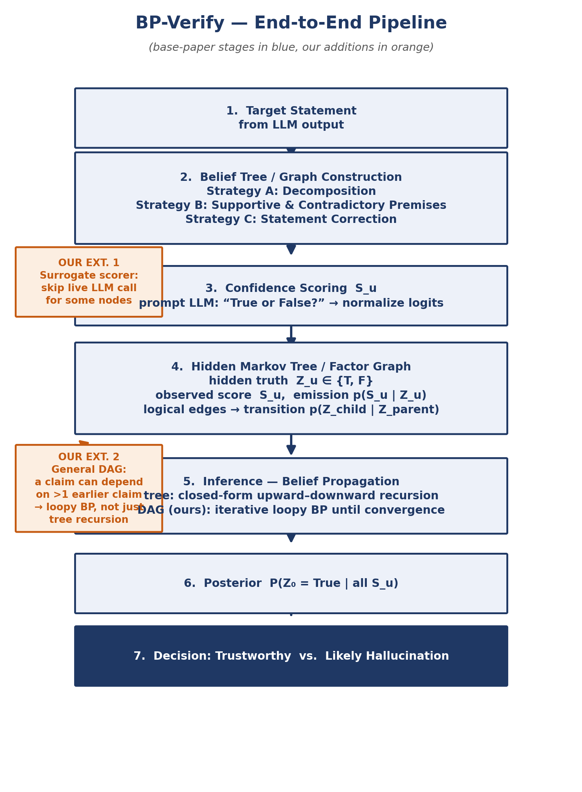
Figure 1 — The full BP-Verify pipeline. Blue stages are the base paper (BTProp); orange callouts are our proposed extensions (Section 3).

2.5 Step 2 — Estimating Confidence Scores
For every node except statement-correction children, the LLM is directly probed with the prompt “True or False? {statement}”, and the model's own next-token probabilities for the words “True” and “False” are normalised into a single confidence score in [0,1]. This score becomes the node's observed variable, Sᵤ, in the hidden Markov tree.

2.6 Step 3 — The Hidden Markov Tree Model
Every node u in the belief tree gets two paired variables: an observed confidence score Sᵤ ∈ [0,1] (what we measured in Step 2), and a hidden true/false variable Zᵤ ∈ {True, False} (what we actually want to know — the claim's real truthfulness). Determining the root's truthfulness becomes computing the posterior probability P(Z₀ = True | all the Sᵤ scores in the tree). Three sets of probabilities make that computable:
- Emission probability, p(Sᵤ | Zᵤ) — how reliable the LLM's confidence score tends to be, given the claim's real truth value. Estimated empirically: take a held-out labelled dataset (the paper uses 120 labelled examples from one benchmark), bin the [0,1] score range into five buckets, and count how often each bucket occurs among statements that are actually true versus actually false.
- Transition probability, p(Z of children | Z of parent) — how the parent's truth value constrains the children's truth values, based on their logical relationship. For decomposition, this is close to deterministic (a true parent forces all children true; a false parent only rules out “all children true”). For premises/corrections, each child is treated as conditionally independent of its siblings given the parent, with a small table of transition values keyed to the four logical-relationship types.
- Prior probability, p(Zᵤ) — the base rate of any arbitrary LLM-generated statement being true before seeing any confidence scores at all. The paper uses an uninformative uniform prior (50/50) throughout.
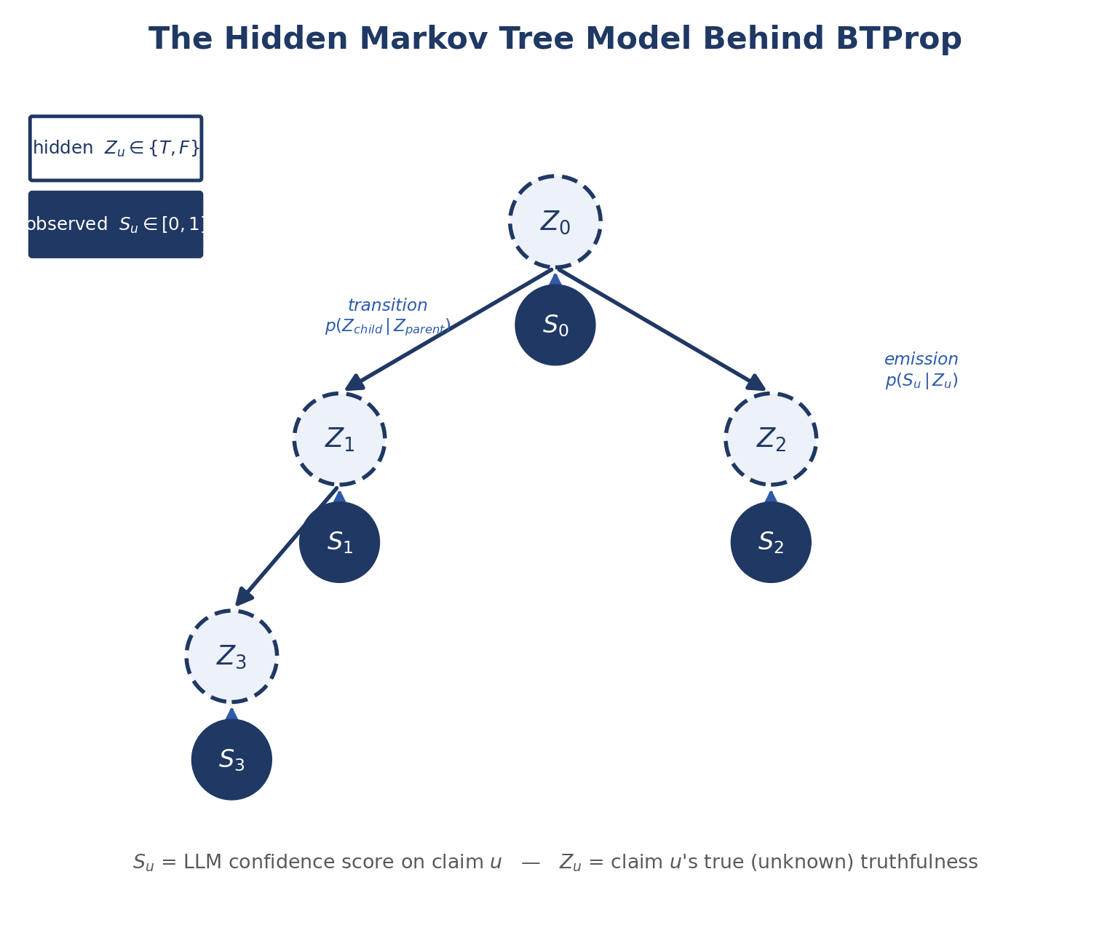
Figure 2 — The two-layer hidden Markov tree: hidden truthfulness Zᵤ (dashed) generates the observed LLM confidence Sᵤ (solid) via the emission probability; parent Z connects to child Z via the transition probability.

2.7 Step 4 — Inference: The Upward-Downward Algorithm
Computing the posterior at the root is a textbook inference problem for hidden Markov trees, solved with the standard upward-downward algorithm — the paper's own text explicitly calls this process belief propagation. The trick is an auxiliary quantity, β(z, u), defined as the probability of observing every confidence score in the sub-tree rooted at u, given that node u's hidden truth value is z.
At a leaf node, β(z, u) is just the emission probability p(Sᵤ | Zᵤ = z) — there's no sub-tree below it to account for. For any internal node, β(z, u) is computed recursively from its children's already-computed β values: multiply the node's own emission probability by a sum, over every possible joint truth-setting of its children, of the transition probability to that setting times the product of the children's β values for that setting. Working from the leaves upward, this recursion eventually produces β(True, root) and β(False, root), and the final posterior is simply their ratio, weighted by the (uniform) prior.
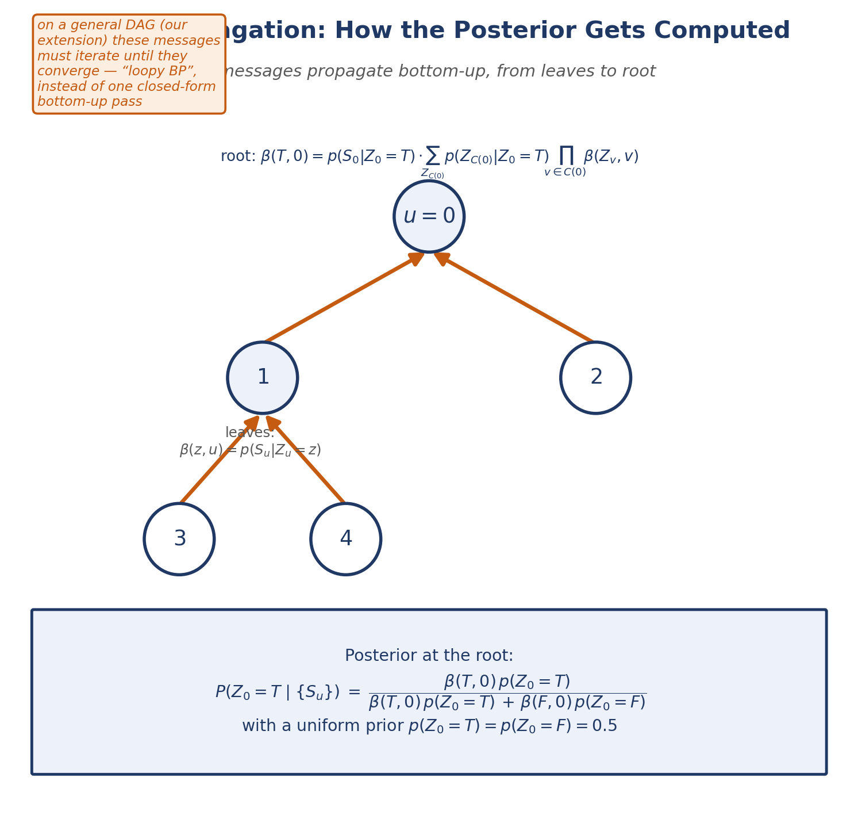
Figure 3 — β messages propagate bottom-up from leaves to root; the boxed formula is the final posterior at the root, exactly as derived in the paper.
In short: leaves start with a known value (their own emission probability), and every parent combines its children's values with its own emission and the transition probabilities — one clean recursive pass, no approximation, because the graph is a tree.

2.8 Experimental Setup
Item | What the paper used
Datasets | Wikibio-GPT3 (LLM-generated biographies), FELM-Science (science-focused, segment-level), FactCheckGPT (broader topics, sentence-level)
Backbones tested | GPT-3.5-turbo-0125 and Llama-3-8B-Instruct
Baselines compared | Prior Confidence, Chain-of-Thought, SelfCheckGPT, Semantic Uncertainty, Maieutic Prompting, Focus (Llama-3 only)
Metrics | AUROC, AUC-PR, F1, detection accuracy
Max tree depth used | 2 (decomposition applied only at the root; correction-generated nodes are not expanded further, to control cost)

2.9 Results — What Actually Happened
Reported honestly, including where the method does not win: BTProp achieves the best AUROC/AUC-PR on FELM-Science and FactCheckGPT, across both backbones, improving over the best baseline by roughly 3–9%. On Wikibio-GPT3, however, SelfCheckGPT is actually the stronger method — the paper is upfront that this is the one exception. On efficiency, sampling-based baselines show diminishing returns as more responses are sampled, while BTProp keeps converting additional tree depth into further performance gains, though it does cost more time per prediction than a single-shot baseline in absolute terms.
The ablation study is genuinely informative: using only one child-generation strategy at a time is clearly worse than combining all three; statement correction alone contributes the most of the three individually, but decomposition-only or premise-only alone can actually underperform simply asking the model for its prior confidence directly — showing the strategies need each other, not that any one of them is sufficient on its own.

2.10 Limitations the Authors Themselves Flag
Straight from the paper's own limitations section: the method's main weakness is its high time cost. Building a belief tree needs many LLM queries, and the number of child nodes needed grows exponentially as tree depth increases. The authors' own suggested fix — which they did not implement — is a mechanism that selectively expands only the most useful nodes instead of the whole tree.
This matters directly for our project: our cost-reduction extension (Section 3.2) is a concrete answer to a gap the original authors themselves left open, not a made-up problem.

2.11 Additional Drawbacks We Identify
- Tree-only structure: every node has exactly one parent by construction. Real multi-step reasoning routinely has a step that depends on two or more earlier steps at once — a DAG, not a tree — which this model cannot represent directly.
- Only tested at shallow depth (2): the paper's own cost concerns forced a shallow tree in practice; how well the approach holds up on deeper, more realistic multi-hop reasoning is untested.
- Evaluated on standalone factual statements (biographies, science trivia, general claims), not on literal multi-step chain-of-thought reasoning traces (e.g. a worked math or logic derivation) — the exact setting a “reasoning-chain verifier” project would ultimately want to target.
- All three benchmark datasets are English-only and general-knowledge in domain; behaviour on structured domains like code or multi-step numerical reasoning is unknown.

3. Our Novelty — What We're Changing, and How

3.1 Extension 1 — From Tree to General Factor Graph (Loopy BP)
What: Generalise the belief tree into a general factor graph (a DAG of claims), allowing a claim to logically depend on more than one earlier claim — which is common in real multi-step reasoning, and which the tree model cannot represent.
How: Replace the closed-form upward-downward recursion with iterative loopy belief propagation: nodes keep exchanging messages with all their neighbours (not just up toward a single parent) for several rounds, until the messages stop changing much (convergence) or a maximum iteration count is hit.
Why it's a fair, honest extension: The syllabus itself teaches that loopy BP on general graphs has no formal convergence guarantee, unlike tree-structured BP. That's not swept under the rug here — it's the actual open question this extension empirically investigates: does it converge on these reasoning-claim graphs in practice, and how does inference quality degrade (or not) compared to the exact tree case?
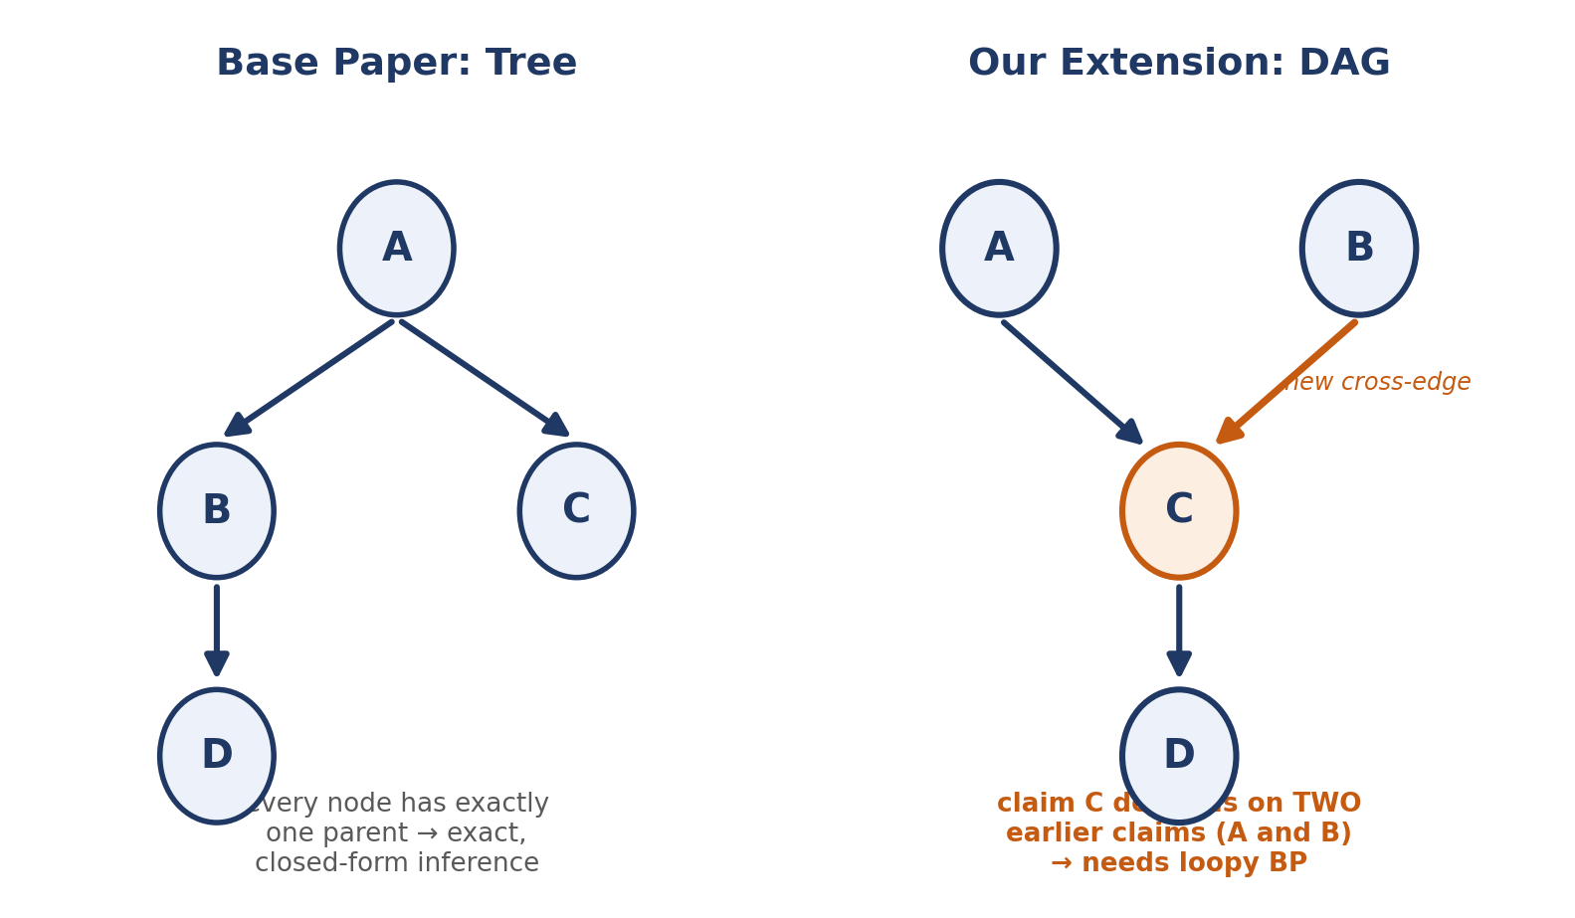
Figure 4 — The base paper's tree (left) vs. our general-DAG extension (right), where a claim can depend on more than one earlier claim.

3.2 Extension 2 — Cost Reduction via a Surrogate Confidence Scorer
What: Cut down the number of live LLM calls needed per verification, directly targeting the exponential-cost problem the base paper's own authors flagged as unsolved future work.
How: During an initial data-collection phase, log every (claim text, LLM confidence score) pair the pipeline produces. Train a small, cheap classifier — a sentence-embedding model feeding a lightweight classifier head — to predict the LLM's confidence score from the claim text alone. At inference time, use this surrogate for a chosen fraction of nodes (e.g. deeper, less critical levels of the tree/graph) instead of a fresh LLM call, falling back to the real LLM only for nodes the surrogate is itself unsure about.
Expected payoff: A tunable accuracy-vs-cost dial: report the full trade-off curve (à la the base paper's own performance-efficiency analysis) between how much is delegated to the cheap surrogate and how much detection quality is lost, giving a concrete, reusable answer to “how much can you save, and what does it cost you” — not just a one-off number.

3.3 Extension 3 (Stretch Goal) — Testing on Real Multi-Step Reasoning Chains
What: Apply and evaluate the whole pipeline on genuine multi-step chain-of-thought traces (e.g. worked math or logic problems where each step's correctness can be checked) rather than only on standalone factual statements, which is the setting all three of the base paper's benchmarks actually use.
Why it matters: This is the actual target use-case implied by “verifying multi-step reasoning chains” — and it is untested territory even in the base paper itself.
Honest scope note: This is marked a stretch goal, not a core deliverable — finding or constructing a suitable step-labelled reasoning-chain dataset is itself real work, and Extensions 1 and 2 alone are already a substantial, defensible semester project.

3.4 Old vs. New, Side by Side
Aspect | Base paper (BTProp) | Our extension
Graph structure | Tree only (one parent per node) | General factor graph / DAG (multiple parents allowed)
Inference method | Exact, closed-form upward-downward | Iterative loopy BP; convergence studied empirically
Cost per verification | One live LLM call per node, every time | Surrogate model handles a tunable fraction of nodes
Evaluation domain | Standalone factual statements (3 benchmarks) | Same, plus (stretch) real multi-step reasoning chains

3.5 Expected Improvement & Honest Trade-offs
Expected: the DAG extension should better reflect real reasoning-chain dependency structure and, if loopy BP converges reliably in this setting, should not lose much accuracy relative to the tree case while covering strictly more realistic graphs. The surrogate scorer should let a large fraction of nodes skip an LLM call at a modest, quantified accuracy cost, directly improving on the base paper's own stated weak point.
Honest trade-offs to state upfront in any report or proposal: loopy BP has no formal convergence guarantee, so some fraction of graphs may need to be flagged as “inference did not converge” rather than silently trusted; and the surrogate scorer's accuracy is only as good as the LLM-confidence data collected to train it, so it needs a reasonably sized, representative logging phase before it can be trusted to replace live calls.

4. Our Step-by-Step Technical Approach
- Reproduce the baseline first. Before touching any extension, rebuild BTProp's own pipeline — the three child-generation strategies, the emission/transition probability estimation, and the upward-downward inference — on a subset of one of its own open datasets (FELM-Science is a good first choice). Confirm the reproduced AUROC is in the right ballpark versus the paper's reported numbers before changing anything. This is a sanity checkpoint, not optional scaffolding.
- Extract dependency graphs from real chain-of-thought traces. Define how a claim's dependency edges are identified beyond simple parent → child: prompt the LLM to state which earlier reasoning steps a given step actually relies on, producing a general DAG instead of only ever building a fresh tree from scratch.
- Implement general loopy belief propagation. Generalise the closed-form β recursion into an iterative message-passing routine that works on any DAG/factor graph, with a convergence check (e.g. messages changing by less than some small threshold) and a hard iteration cap as a safety net.
- Validate inference correctness on synthetic graphs first. Before running it on real LLM claims, test the loopy-BP implementation on small, hand-constructed graphs with a known, hand-computed correct posterior, to catch implementation bugs early and cheaply.
- Build the surrogate confidence scorer. Log (claim text, LLM confidence) pairs during Steps 1–2, embed claim text with a pretrained sentence-embedding model, and train a lightweight classifier/regressor to predict the confidence score; validate it against held-out real LLM scores before using it in the live pipeline.
- Assemble the full extended pipeline. Combine the DAG dependency extraction, loopy BP inference, and the surrogate scorer (used for a configurable fraction of nodes) into one end-to-end system, mirroring the architecture in Figure 1.
- Build the evaluation harness. Reuse the base paper's own metrics (AUROC, AUC-PR, F1, accuracy) for direct comparability; for the standalone-statement benchmarks, reuse their existing ground-truth labels, for the reasoning-chain extension, use or construct a small step-labelled evaluation set.
- Run the comparisons that matter. At minimum: original tree-only BTProp vs. our DAG+loopy-BP version (does generalising the structure cost or gain accuracy?); full live-LLM scoring vs. surrogate-assisted scoring at several delegation fractions (what's the accuracy-cost curve?).
- Ablate and analyse failure cases. Vary loopy-BP's convergence threshold/iteration cap and the surrogate's delegation fraction; look at specific graphs where inference disagrees with ground truth or fails to converge, the same way the base paper itself walks through qualitative belief-tree examples.
- Write it up. Results, an honest account of what worked and what didn't, and — if the numbers are strong — a look at whether it's workshop-paper shaped.

5. Prerequisites, Stack & Tools

5.1 Concepts You Should Be Comfortable With Before Starting
- Bayes' Rule and conditional probability (early syllabus material).
- Markov networks, factor graphs, message passing / belief propagation, and why trees give exact inference while general graphs need the loopy variant (current syllabus material — you're learning this at the same time as the project, which is intentional).
- Hidden Markov Models: transition probability, emission probability, and the forward-backward-style recursion (syllabus material; this project's HMT is the direct tree-shaped generalisation).
- Basic classifier training (logistic regression or a small MLP) for the surrogate scorer — standard ML, not specific to this project.

5.2 Technical Stack
Layer | Recommended tool(s) | Why
Language | Python 3.10+ | Matches the base paper's own released code, so you can directly compare against/extend it.
LLM access | An LLM API (e.g. a GPT-family model) and/or a locally-hosted open model (e.g. Llama-3-8B-Instruct via vLLM or Hugging Face Transformers) | The base paper tests both a closed API model and an open model — using both keeps results comparable to their Table 3.
NLI model | A pretrained NLI model from Hugging Face (e.g. a RoBERTa-MNLI-style checkpoint) | Needed to determine entailment/contradiction/neutral between parent and child claims (Strategies B/C).
Graph representation & inference | networkx for representing the tree/DAG; custom Python for the β-recursion and loopy-BP message passing | networkx makes traversal, cycle detection, and visualisation straightforward; the inference math itself is simple enough to implement directly rather than pulling in a heavyweight PGM library.
Surrogate scorer | sentence-transformers for claim embeddings; scikit-learn (logistic regression / gradient boosting) or a small PyTorch MLP for the classifier head | Lightweight, fast to train on CPU, no GPU strictly required for this component.
Evaluation | scikit-learn (roc_auc_score, average_precision_score, f1_score) | Matches exactly what the base paper itself uses, keeping your numbers directly comparable.
Experiment tracking & plotting | pandas, matplotlib | For ablations, convergence curves, and the accuracy-vs-cost trade-off plot.

5.3 Datasets
- FELM-Science and FactCheckGPT — both used directly by the base paper (open licenses: FactCheckGPT is Apache-2.0; FELM is CC-BY-NC-SA-4.0) — use these for the baseline-reproduction step and for direct, apples-to-apples comparison.
- Wikibio-GPT3 (CC-BY-SA-3.0) — useful as a second reproduction check, and notable because it's the one dataset where the base paper doesn't win, worth understanding why.
- For the reasoning-chain stretch goal, look for an existing step-annotated chain-of-thought / reasoning-verification benchmark rather than hand-labelling one from scratch if at all possible; if nothing suitable is found, a small, carefully hand-labelled set of 50–100 worked problems (e.g. grade-school or competition math with known step-level errors) is a realistic fallback.

5.4 Compute
No GPU is strictly required for the core contribution — the loopy-BP and surrogate-scorer components run comfortably on CPU, and the LLM itself can be accessed via API. A GPU is only useful if you choose to run Llama-3-8B-Instruct locally as your open-weight backbone (as the base paper does); a free-tier cloud GPU (e.g. Colab) is enough for that.

6. Phase-by-Phase Project Plan
Framed in rough weekly blocks — align these to your course's actual Mid-Semester and Final review dates once announced; the ordering and dependencies between phases matter more than the exact week numbers.
Phase | Focus | Milestone / deliverable
0 (now) | Finalise and submit the one-page abstract for the Zeroth Review; confirm the exact submission deadline with your faculty. | Abstract submitted via the MS Form + logged in the shared duplication-check sheet.
1 (wk 1–2) | Read the base paper in full alongside this document; set up the repo, LLM API access, and reproduce a tiny slice of the official BTProp code to confirm the environment works. | Environment running; official BTProp code executes on a handful of examples.
2 (wk 3–4) | Full baseline reproduction on FELM-Science; confirm reproduced AUROC is close to the paper's reported number. | A working, verified reimplementation of BTProp — your sanity-check milestone.
3 (wk 5–6) | Implement DAG dependency extraction and general loopy BP; validate on small synthetic graphs with known answers before touching real data. | Loopy-BP inference verified correct on synthetic test cases.
4 (wk 6–7) | Build, train, and validate the surrogate confidence scorer against real LLM scores. | Surrogate model with a measured accuracy-vs-LLM-agreement number.
5 (wk 8–9) | Assemble the full extended pipeline; begin work on the reasoning-chain stretch goal if time allows. | End-to-end system running on both standalone claims and (if reached) reasoning chains.
6 (Mid-sem review) | Present: reproduction results, DAG/loopy-BP validity findings so far, and the project's positioning relative to the base paper. | Mid-sem review presentation.
7 (wk 11–13) | Full evaluation: tree-vs-DAG comparison, surrogate accuracy-cost curve, ablations, failure-case analysis. | Complete results tables and plots, mirroring the base paper's own analysis style.
8 (Final review) | Writeup and polish; assess whether results are strong enough to shape into a workshop-paper submission. | Final report / demo + (optional) draft write-up for external submission.

7. How This Maps to 22AIE301
- CO1 (create probabilistic models for uncertain knowledge) — the entire hidden Markov tree / factor graph formulation of LLM claims.
- CO2 (apply Bayesian and Markov formalisms to real problems) — the emission/transition/prior structure, applied to a genuine reliability problem.
- CO3 (apply probabilistic reasoning for complex decision-making) — turning a noisy set of LLM confidence scores into one trustworthy go/no-go judgement.
- CO4 (apply modern computational tools) — LLM APIs, NLI models, and embedding-based surrogates, wired into a classical inference algorithm.
- Direct syllabus topics exercised: Markov Networks, Message Passing / Belief Propagation, Hidden Markov Models, Approximate Inference (loopy BP), Uncertain Knowledge Representation.

One-line summary to keep in your back pocket for any review: “We verify LLM reasoning by modelling each claim's truthfulness as a hidden variable in a probabilistic graphical model, observing the LLM's own noisy confidence scores, and using belief propagation to compute a corrected, logically-consistent posterior — generalising a NAACL 2025 method from trees to general reasoning graphs, and making it cheaper to run.”

